An Empiricist’s Guide To Modern Coexistence Theory

Should mention it is empiricists’ guide for fluctuation independent mechanisms of the modern coexistence theory. Fluctuation independent means the dynamics of resources, either biological or nonbiological, are not affected by the focal species, e.g. in a chemostat. In other word, this means the methods here are calculating the first order approximation of invasion growth rate of the focal species, which is the key metric leading to mutual invasibility criteria.

1. **Introduction** 
   1. Big-picture of why MCT is the best tool we have for evaluating coexistence of species.
   2. Multiple methods have been proposed for evaluating the potential for coexistence among species using empirical data. Although each of these methods is designed to evaluate Chesson’s inequality criterion, it remains unclear 1) whether these methods are functionally equivalent and 2) which methods are most appropriate for a given study system.
   3. We compare five different methods that have been proposed for evaluating coexistence and ask ….
   4. Should mention it is empiricists’ guide for fluctuation independent mechanisms of the modern coexistence theory. Fluctuation independent means the dynamics of resources, either biological or nonbiological, are not affected by the focal species, e.g. in a chemostat. In other word, this means the methods here are calculating the first order approximation of invasion growth rate of the focal species, which is the key metric leading to mutual invasibility criteria.
2. **Describing the theoretical background for the five commonly used empirical methods**

The frequency independent part of the modern coexistence framework is funded on Chesson’s key insight toward the mutual invasibility criterium. The mutual invasibility criterium means, for any two species (e.g. *i* and *j*) to stably coexist each of them must be able to invade the carrying capacity state of other one from rare. In other word, when the mutual invasibility criteria is met, both species have positive invasion growth rate. To have positive invasion growth rate, the species must limit themselves more than they limit their competitor, i.e. *per capita* intra-specific competition coefficients (*αii* or *αjj*) must be greater than *per capita* inter-specific competition coefficient (*αij* or *αji*). Chesson showed that the mutual invasibility criteria i.e. *αii* > *αij* and *αjj* > *αji*, can be expressed in a different fashion (Chesson 1990, 2000). Note that, when making the following deductions, Chesson assumes that species’ population dynamics can be described by Lotka-Volterra model and the *per capita* competition coefficients (*α*) are density independent. First, Chesson defined the niche overlap (*ρ*) as $\sqrt{\frac{α_{ij}α_{ji}}{α_{ii}αjj}}$ to describe how similar the two competing species are in terms of using resources. First, Chesson defined the niche overlap (*ρ*) as $\sqrt{\frac{α_{ij}α_{ji}}{α_{ii}αjj}}$ to describe how similar the two competing species are in terms of using resources. The niche difference (ND) is thus 1 − *ρ*. Second, Chesson defined relative fitness difference (RDF; $\frac{f_{j}}{f_{i}},$ the *fi* is the same as the *ki* in Chesson 1990) as $\frac{α_{ij}}{α_{jj}}\frac{1}{ρ}=\sqrt{\frac{α_{ij}α_{ii}}{α_{jj}α_{ji}}}$ to describe which species should exclude the other one if they completely overlap their resource use. Accordingly, the product of *ρ* and RFD is the ratio of inter- specific to intra-specific competition coefficients, i.e. $\frac{α_{ij}}{α_{jj}}=\frac{f_{j}}{f_{i}}$. When intra-specific competition of species *j* is greater than inter-specific competition of species *i* ($α_{jj}>α_{ji}$), $\frac{α_{ij}}{α_{jj}}=\frac{f_{j}}{f_{i}}ρ<1$ so that $\frac{f_{j}}{f_{i}}<\frac{1}{ρ}$. By the same logic, when intra-specific competition of species *i* is greater than inter-specific competition of species *j* ($α_{ii}>α_{ij}$), $\frac{f_{i}}{f_{j}}<\frac{1}{ρ}$. Consequently, the mutual invasibility criteria for stable coexistence can be rewritten as the following inequality for coexistence.

$ρ<\frac{f_{2}}{f_{1}}<\frac{1}{ρ}$ (1)

We now introduce five commonly used methods to empirically measure *per capita* competition coefficients (*α*) and thus ND, RFD and finally Chesson’s inequality for coexistence (eqn. 1).

* 1. **Negative Frequency dependency (NFD) method**

The most commonly used empirical method to measure *per capita* competition coefficients (*α*) is the negative frequency method (Adler et al. 2007, Levine andHilleRisLambers 2009). Based on the mutual invasibility criterium, the rationale of NFD is to measure how the *per capita* growth rate of a focal species *i* would be affected by the increase of its own the frequency (%), not the density, in a community (Adler et al. 2007). If the intra-specific competition coefficient is greater than the inter-specific competition coefficient, i.e. the focal species *i* is more limited by its own than by its competitor, increasing relative frequency of the focal species *i* will thus decrease its own *per capita* growth rate. In this case, frequency dependency is negative because *per capita* growth rate of the focal species *i* negatively depends on its own frequency. On the contrary, if inter-specific competition is greater, frequency dependency should be positive as the *per capita* growth rate of the focal species *i* increase with its own frequency. Given this rationale, we argue that negative frequency is to be expected when the focal species *i* limits itself more than it limits its competitor, i.e. intra-specific competition coefficient is greater than inter- specific competition coefficient. Therefore, as long as the frequency dependency is negative, species should be guaranteed to stably coexistence.

However, we argue that the magnitude of negative frequency dependency (the slope) is not equivalent to either intra- or inter-specific competition coefficients [6] but a rather complex combination between both. When calculating negative frequency dependency (NFD), the per capita growth rate is being plotted against the frequency of the focal species, so it is actually the ”per %” impact on the per capita growth rate. Here we show how the NFD is not equivalent but related to the competition coefficients in the Lotka-Volterra model.

To show that negative frequency dependency (NFD) metrics cannot be used directly to measure competition coefficients (*α*), we attempt to derive the NFD metrics from the Lotka-Volterra model. We found that, the NFD metrics cannot be readily derived from the Lotka-Volterra model without making further assumptions. First, there is only density term but no frequency term in the Lotka-Volterra model. Only when the community density is fixed, the density dependency, *αij*, is equivalent to density dependency (Adler et al. 2007). In addition, since the density dependency, *αij*, is modeled in *per capita* fashion, one-to-one conversion between the focal species *i* and its competitor also needs to be assumed. By doing so, the Lotka-Volterra competition model can be rewritten as followed.

$\frac{1}{N_{i}}\frac{dN_{i}}{dt}=r_{i}\left(1-α_{ii}N_{i}-\sum_{j≠i}{α_{ij}\left(B-N_{i}\right)}\right)$ (2)

In equation 2, *B* is the fixed community density and one unit decrease of *Ni* will lead to one unit increase of *Nj*. Note that this *B* is an arbitrarily defined constant describing a fixed community density and has nothing do to with the equilibrium of any of the species. To calculate the negative frequency dependency (NFD) metrics, we take derivative of equation 6 in terms of Ni/B.

$NFD≡\frac{∂\frac{1}{N_{i}}\frac{dN_{i}}{dt}}{∂\frac{N_{i}}{B}}=\frac{∂\frac{1}{N_{i}}\frac{dN_{i}}{dt}}{\frac{1}{B}∂N_{i}}=B\frac{∂\frac{1}{N_{i}}\frac{dN_{i}}{dt}}{∂N_{i}}=Br_{i}\left(α_{ij}-α_{ii}\right)$ (3)

This equation 3 describe the change of species *i*’s *per capita* growth rate with respective to the change of its own frequency in a community (Fig. 1). From equation 3 the NFD depends on a combination of *per capita* growth rate (*ri*) and the fixed community density (*B*) in addition to the intra- and inter-specific competition coefficients. From this equation, we first see that NFD is negative as long as the intra-specific competition (*αii*) is greater than the inter-specific competition (*αij*). Additionally, higher *per capita* growth rate of a species and higher community density (e.g. in the later more mature stage of the community) would lead one to estimate stronger frequency dependency (Fig. 1). Most importantly, although NFD metrics has been used to estimate species coexistence empirically for annual plant communities (e.g. Godoy et al. 2014), NFD should be interpreted with caution as it is related but not equivalent to the competition coefficients (*αii* and *αij*) and thus should not be directly used to calculate ND and RFD, and to predict species coexistence.

* 1. **Fitting the classic Lotka-Volterra model**

The second empirical method is to parameterize the Lotka-Volterra model with empirical data. In the classic Lotka-Volterra model, the *per capita* growth rate of species i can be described by the following equation.

$\frac{1}{N_{i}}\frac{dN_{i}}{dt}=r_{i}\left(1-α_{ii}N_{i}-\sum_{j≠i}{α_{ij}}N_{j}\right)$ (4)

In the above equation, *Ni* and *ri* are the the density and the intrinsic growth rate of species *i* respectively. The *αii* is the *per capita* intra-specific competition coefficient, which describes the *per capita* effect of species *i* on the *per capita* growth rate of species *i*. The *αij* is the inter-specific competition coefficient, which describes the *per capita* effect of species *j* on the *per capita* growth rate of species *i*. For any two species (e.g. *i* and *j*) to stably coexist, the mutual invasibility criteria must be met, i.e. *αii* > *αij* and *αjj* > *αji*.

To use the Lotka-Volterra model to empirically predict coexistence for species *i* and *j*, one must first estimate six different parameters that are used in the Lotka-Volterra model: intrinsic growth rate of each species (*ri* and *rj*), *per capita* intra-specific competition coefficients (*αii* and *αjj*), and *per capita* inter-specific competition coefficients (*αij* and *αji*). In theory, this could be accomplished using maximum likelihood method from a single co-culture time-series dataset, where both species are introduced at low density and allowed to grow to steady-state. However, in practice, it is difficult to parameterize all six variables from a single time-series. An alternative would be to use three datasets for each species pair: each species as a monoculture and one co-culture of the two species (Fig. 2). With the empirically estimated competition coefficients, one can calculate the niche difference (ND), relative fitness difference (RFD) and access Chesson’s coexistence inequality. An important consideration is that, the Lotka-Volterra model assumes constant intra- and inter-specific competition coefficient with respect to population sizes and time, which means the first individual and the last individual have the same *per capita* effect on the growth rates.

* 1. **Sensitivity method**

The sensitivity method is another method proposed to measure niche difference (ND) and relative fitness difference (RFD) without explicitly estimating the inter-specific competition coefficients (Carroll et al. 2011). Instead, sensitivity method relies on the effect of inter-specific competition on the population dynamics. Sensitivity method is also based on the idea of mutual invasibility that species need to be able to invade its competitor from rare in order to coexist (Fig. 3). The rationale is that when the focal species *i* overlaps its niche with its competitor, the *per capita* growth rate of the focal species *i* should be lower when invading its competitor than when growing alone from rare. The more the focal species *i* overlaps its niche with its competitor, the lower invading *per capita* growth rate species *i* should have. The sensitivity metric (*Si*) is being designed to quantify such decrease and thus to quantify the effect of the competitor on the focal species *i*. Specifically, the sensitivity metric (*Si*) compares the focal species *i*’s *per capita* growth rate when invading its competitor versus the focal species *i*’s *per capita* growth rate when growing alone from rare. The difference between the two growth rates is then the proxy of the effect of competitor on the focal species *i*. If either species has a growth rate less than or equal to zero when invading, the *Si* is then no less than 1, which means that there will not be coexistence (mutual invasion criterion). According to Carroll et al. 2011, sensitivity metric (*Si*) is calculated by the following formula.

$S_{i}≡\frac{μ_{i}-μ_{ij}}{μ_{i}}$ (5)

In equation 5, *μi* is the *per capita* growth rate of species *i* when growing alone from rare and *μij* is the *per capita* growth rate of species *i* when it competitor (species *j*) is at its carrying capacity. Such mutual invasion experiment not only directly tests for mutual invasibility, but also empirically estimates ND and RFD [Carroll 2011]. Therefore, the mutual invasion experiment used to estimate the sensitivity metric (*Si*) is not restricted to a specific competition model, and intuitively connects competition and population dynamics [Carroll 2011]. Here, we further this intuitive connection by showing that the sensitivity metric actually describe the impact of the entire competitor population on the *per capita* growth rate of focal species *i*. From equation 5, the reduction of species *i*’s per capita growth rate, i.e. the nominator, is actually caused by the entire population of the other species *j* because the invasion growth rate (*μij*) is measured when the other species *j* is at the carrying capacity. Accordingly, the sensitivity (*Si*) measures the ”population” impact of species *j*, but not the per capita impact of species *j* on the focal species *i*.

To show that sensitivity is actually the population level impacts, not the *per capita* level, we derive the sensitivity metric (*Si*) from the classic Lotka-Volterra competition model (equation 4). The *μi* and *μij* in equation 5 are therefore *ri* and *μij* is $r_{i}(1-α_{ij}N_{j}^{*})$ respectively. Accordingly,

$S_{i}≡\frac{μ_{i}-μ_{ij}}{μ_{i}}=\frac{r_{i}-r_{i}\left(1-α_{ij}N_{j}^{*}\right)}{r_{i}}=α_{ij}N_{j}^{*}$ (6)

From equation 6, we see that sensitivity (*Si*) is the equilibrium density of species *j* ($N_{j}^{*}$) times the *per capita* competition coefficient (*αij*). The sensitivity thus is a measurement of the overall population effect of species *j* on focal species i but not the ”*per capita*” effect of species *j*. Small tweak should be implemented when using the sensitivity method to estimate per capita inter-specific competition coefficients (*αij*).

Moreover, Carroll et al. 2011 verbally argued that niche difference (ND) and relative fitness difference (RFD) can be defined as the geometric mean and standard deviation of the sensitivity metric (*Si*) respectively. Here we show that geometric mean and standard deviation of sensitivity metrics are theoretical valid definitions of ND and RFD. In the Lotka-Volterra model, species’ density at the equilibrium (*N\**) is actually $\frac{1}{α_{ii}}$. Therefore, sensitivity (*Si*) can be expressed as $\frac{α_{ij}}{α_{jj}}$, which represents the inter-specific competition scaled on intra-specific competition coefficient. According to Chesson (1990), niche overlap ($ρ$) is defined as $\sqrt{\frac{α_{ij}α_{ji}}{α_{ii}α_{jj}}}$. $\sqrt{\frac{α_{ij}α_{ji}}{α_{ii}α_{jj}}}$ can then be expressed as $\sqrt{S_{i}S_{j}}$*,* which is the geometric mean of sensitivity *Si* and *Sj*. The niche difference (ND) is therefore $1-ρ=1-\sqrt{\frac{α_{ij}α_{ji}}{α_{ii}α_{jj}}}=1-\sqrt{S_{i}Sj}$*.* In addition, $\sqrt{\frac{S_{i}}{S_{j}}}=\sqrt{\frac{α_{ij}α_{ii}}{α_{jj}α_{ji}}}$, and $\sqrt{\frac{α_{ij}α_{ii}}{α_{jj}α_{ji}}}$ is the definition of the inverse of relative fitness difference of species *j* over species *i* (RFD; $\frac{k_{j}}{k_{i}}$ in Chesson 1990).

With the above derivation, we can also derive the coexistence criteria using the sensitivity metric. From the Lotka-Volterra model model, intra-specific competition (*αii*) must be greater than the inter-specific competition (*αij*) to guarantee stable coexistence. Therefore, we can have the following deduction.

$\frac{α_{ij}}{α_{jj}}=\sqrt{\frac{α_{ij}α_{ii}}{α_{jj}α_{ji}}}×\sqrt{\frac{α_{ij}α_{ji}}{α_{ii}α_{jj}}}=\sqrt{\frac{S_{i}}{S_{j}}}×ρ<1$, so $\sqrt{\frac{S_{i}}{S_{j}}}<\frac{1}{ρ}$ (7)

$\frac{α_{ii}}{α_{ji}}=\sqrt{\frac{α_{ii}α_{ij}}{α_{ji}α_{jj}}}×\sqrt{\frac{α_{ii}α_{jj}}{α_{ij}α_{ji}}}=\sqrt{\frac{S_{i}}{S_{j}}}×\frac{1}{ρ}<1$, so $\sqrt{\frac{S_{i}}{S_{j}}}>ρ$ (8)

Combining equation 7 and 8, we have an inequality for coexistence expressed with sensitivity metrics, $ρ<\sqrt{\frac{S_{i}}{S_{j}}}<\frac{1}{ρ}$, which is in the same form as in Chesson’s coexistence framework. In brief, the sensitivity metric (*Si*) is not equivalent to the competition coefficient (*αij* in the Lotka-Volterra model), but due to its methmatic attributes, it can be used to calculate ND and RFD and to predict coexistence directly.

* 1. **Fitting the MacArthur’s consumer resource model**

The consumer resource model proposed by MacArthur in 1970s is used to describe how species compete for different prey resources (MacArthur 1969, 1970). This model is reorganized into a Lokta-Volterra form to more closely understand the rather phonological competition coefficients (*α*) between competing species (Chesson 1990, 2000). After the reorganization shown in(Chesson 1990), the following equation represent the linkage between the Lottka-Volterra model and the parameters of MacArthur’s consumer resource model.

$α_{ij}=\sum_{l}{c_{il}}c_{jl}\frac{w_{l}K_{l}}{r_{l}}$ (9)

$f_{i}=\sum_{l}{c_{il}}w_{l}K_{l}-m_{i}$ (10)

Left-hand side of equation 9 and 10 consists of parameters in the Lotka-Volterra model, while the right-hand side consists of parameters from MacArthur’s consumer resource model. On the left-hand side, *αij* is the competition coefficient and *fi* is per capita growth rates of the species *i* in the absence of resource limitation, which determines the winner of the competition (Chesson 2000). On the right-hand side, *cil* and *cjl* are the consumption of species *i* and *j* on resource *l* respectively, *mi* is the mortality of species *i*, *wi* is the value of one unit of resource *l* to the species, and *rl* and *Kl* are the *per capita* growth rate and carrying capacity of resource *l*. Through this linkage, empirically measured parameters in MacArthur’s consumer resource model can be translated into parameters in Lotka-Volterra model and thus be used to calculate niche difference (ND) and relative fitness difference (RFD) and finally access Chesson’s coexistence inequality.

* 1. **Fitting the Tilman’s resource ratio model**

Similar to MacArthur’s consumer resource model, Tilman’s resource ratio consumer resource model (Tilman 1977) can also be translated to a Lotka-Volterra form(Letten et al. 2017). Letten et al. 2017 reorganize Tilman’s two-species consumer resource model for two essential resources to the following Lokta-Volterra form (equation 11 to 14), so that one can decipher the parameters impacting species’ *per capita* growth rate. According to Letten et al. the inter- and intra-specific competition coefficients can be expressed as following,

$α_{ii}=\frac{c_{ij}}{D\left(S_{j}-R_{ij}^{*}\right)}$ (11)

$α_{ij}=\frac{c_{jj}}{D\left(S_{j}-R_{ij}^{*}\right)}$ (12)

$α_{jj}=\frac{c_{ji}}{D\left(S_{i}-R_{ji}^{*}\right)}$ (13)

$α_{ji}=\frac{c_{ii}}{D\left(S_{i}-R_{ji}^{*}\right)}$ (14)

In the above equations, *cij* is the consumption term of consumer species *i* on resource *j*, so it contains a parameter *yij* that representt the yield of consumer species *i* per resource *j*. *D* is the dilution rate, *S* is the supply rate of resource *i*, and R* is the minimum resource density of resource *j* that still allows the species *i* to have positive *per capita* growth rate.

Note that, in the generic consumer resource model, each consumption terms (*cij*) is a function of resource density, e.g. $c_{ij}=\frac{r_{i}R_{j}}{y_{ji}\left(R_{j}+K_{ij}\right)}$ in Tilman’s 1977 deduction. However, if the consumption term is resource density dependent, competition coefficients (*αij*) becomes resource dependent. In other words, if the consumption term is resource density dependent and thus not fixed, estimate of niche difference (ND), relative fitness difference (RFD) and finally Chesson’s coexistence inequality will also vary. Therefore, Letten et al.’s derivation should be used to predict coexistence based on the mutual *per capita* effects of each species on the other at equilibrium. To use Letten et al.’s derivation (equation 11 to 14) to calculate competition coefficients for predicting coexistence at the equilibrium, one would have to assume that the consumption of species *i* on resource *j* is evaluated at the equilibrium. For example, when at equilibrium, consumer’s consumption (*cij*) should be equal to the dilution rate (*D*) divided by the yield of consumer (*yij*). In another words, the *αij* describes impact of species *j* on the *per capita* growth rate of species *i* when the resource that limits species *j* is at the equilibrium, i.e. at the R* level (R*jj). This assumption is the same as the sensitivity method since both methods assume the competing species to be at the equilibrium. This assumption is also valid because the mutual invasibility criteria also assume the competing species to be at the equilibrium.

1. **Compare the five commonly used empirical methods**

After describing the theoretical background, we compare these five methods in terms of (1) whether they are identical with respective to the algebra for calculating niche difference (ND) and relative fitness difference (RFD) as well as (2) whether they make the same coexistence prediction. In Table 1, we compare whether the five methods are identical when using their metrics to calculate niche difference (ND; $1-ρ=1-\sqrt{\frac{α_{ij}α_{ji}}{α_{ii}αjj}}$) and relative fitness difference (RFD; $\frac{f_{j}}{f_{i}}=\sqrt{\frac{α_{ij}α_{ii}}{α_{jj}α_{ji}}}$). The metric of each method is listed in the parenthesis following the name of each method. We see that the negative frequency dependency is the outlier as the slope of frequency is a complex combination of *per capita* growth rate (*ri*) and the fixed community density (*B*) in addition to *per capita* the intra- and inter-specific competition coefficients. Except NFD, the Lotka-Volterra model and the sensitivity method are identical in terms of the algebra for ND and RFD calculation (eqn. 7 and 8). Both consumer-resource models are also identical with the Lotka-Volterra model and the sensitivity method because one can simply reorganize the parameters in the consumer-resource models to the Lotka-Volterra form and derive ND and RFD.

In terms of whether the five methods make qualitatively the same coexistence predictions when applying these methods in real experiment (Table 2), we see that, again, the NFD method differs from the other four. This is due to the fact that the slope of the negative frequency dependency is not equivalent to the competition coefficients (*αii* and *αij*) and thus should not be directly used to calculate ND and RFD, and to predict species coexistence. Other then NFD, the other four methods are qualitatively the same when predicting species coexistence under some assumptions. Specifically, it is assumed that the competition coefficients (*αii* and *αij*) in the Lotka-Volterra model is density independent, which means the competition coefficients (*αii* and *αij*) is constant with respect to time and population density. The constant competition coefficients assumption is also the assumed in the sensitivity method but not necessary in the two consumer-resource models.

In the two consumer-resource models, the impact of the competing species (*j*) on the focal species (*i*) one depends on competing species *j*’s consumption on the resource that limit the growth of the focal species. For example, in Tilman’s consumer-resource model, the *per capita* competition of species *j* on *i* ($α_{ij}=\frac{c_{jj}}{D\left(S_{j}-R_{ij}^{*}\right)}$) depends on the consumption of species *j* on resource *j* (*cjj*), which is the limiting resource of species *i*. Although we assume that the consumption of species *i* on resource *j* is evaluated at the equilibrium when applying equation 11 to 14, this might not reflect the reality in the experiment system. In addition, the resource levels under which the experiment is conducted can affect the parameter estimation in the consumer resource models and thus affect the calculation of competition coefficients (*αii* and *αij*) and ND and RFD. For example, the R* is the Tilman’s consumer-resource model is determined by the dilution rate (*D*) so that under different dilution rate, the *per capita* competition coefficients (e.g. $α_{ij}=\frac{c_{jj}}{D\left(S_{j}-R_{ij}^{*}\right)}$) and thus ND and RFD can vary. Consequently, the prediction to species coexistence can be different from that from the Lotka-Volterra model fitting or sensitivity methods.

In conclusion, we argue that, except the NFD method, these five methods are identical in terms of the algebra to calculate *per capita* competition coefficients and thus ND and RFD. However, when applying these methods in real experiment, the two consumer-resource models can make qualitatively different coexistence predictions when the *per capita* competition coefficients is not constant with respective to time and population size.

1. **When, why, and how each method should be used (narrative for the table)**
   1. Having summarized each method and its principles of operation, an empiricist is left to determine which method(s) are most appropriate for their study system, experimental approach, and goals. The upper section of Table 1 is a decision tree that divides the five methods with respect to several sequential bifurcations.
      1. The first bifurcation is whether or the empiricist knows the factors that influence population dynamics in their study system [Q1]. This question divides the five methods into two completely separate groups: phenomenological methods that are informed by quantifying species interactions but make no assumptions about mechanisms (highlighted in red), and two methods based on consumer resource models in which species are assumed to interact only through specific mechanisms (highlighted in blue).
      2. As shown in section 2, both of the consumer resource models can be used to estimate interaction coefficients and obtain estimates of ND and RFD. However, none of the phenomenological methods can be used to predict the mechanisms by which species interact in consumer-resource models.
      3. Due to the completely divergent properties of these two classes of models, several of the remaining decision steps are specific to either of the consumer-resource models or the phenomenological methods.
   2. Phenomenological Methods.
      1. The three phenomenological methods highlighted in red are similar in that an empiricist does not need to know which mechanisms regulate population dynamics, whether the species are competing for a resource, or what type of resource (biotic or abiotic) the species are competing for.
      2. One of the most consequential decisions among these methods is whether the data will come from manipulative experiments or observations from an un-manipulated system [Q2]. All three phenomenological methods will work for manipulative experiments, but only the NFD method has been applied to observational data in order to predict coexistence. This determinant is particularly important for study systems where manipulation is not feasible (e.g. long-lived species, protected habitats).
      3. Another bifurcation among the three phenomenological methods is whether the method requires data measured in monocultures [Q3]. The negative frequency dependence method is distinct because it is does not require monocultures. The Lotka-Volterra and Sensitivity methods are further distinguished by the need for each species to be grown at steady state as monocultures [Q4], either to measure steady-state abundance (i.e. carry capacity) or as a resident population for invasion experiments.
      4. The final determinant among the phenomenological methods is whether the method can be generalized to predicting coexistence among multiple species [Q5]. Theoretically, when predicting species coexistence between multiple species, the Lotka-Volterra model can consider other species individually, while the sensitivity and negative frequency dependency methods require that the other species are considered in aggregate. In other words, fitting the Lotka-Volterra model allows an empiricist to obtain the pairwise interaction coefficients for all species and thus can predict coexistence between the focal species versus the multiple species in aggregate. On the other hand, the sensitivity and negative frequency dependency methods can only be used to predict coexistence between the focal species versus the multiple species in aggregate.
      5. When using any of these phenomenological methods for more than two species at a time, an empiricist would need to assume that the multiple species consortia already stably coexist before the presence of the focal species. In addition, an empiricist would need to assume that with the impact from the multiple species aggregate on the focal species remain the same with the presence of the focal species. However, none of these three methods can deal with intransitive competition, where competition among species can be non-hierarchical.
   3. Consumer-Resource Methods.
      1. The consumer-resource models are differentiated primarily based on whether the resource is abiotic and governed by a constant rate of supply (e.g. inorganic nutrients consumed by plants) or biotic and has its own population dynamics [Q6].
      2. Another characteristic that distinguishes the consumer-resource models is the number of resources that are considered. Specifically, Letten et al [2017] demonstrated that the consumer-resouce model can be used for two abiotic resources, so it remains unclear whether the method could be expanded to consider information about additional resources. In contrast, the method based on MacArthur’s consumer-resource model works for systems where the number of relevant resources is very large.
      3. While the consumer-resource model methods have certain advantages, these methods can only be applied in a limited subset of cases where the empiricist knows all of the factors that affect the population dynamics of the species.
   4. Having considered the questions under the section ‘Decision Steps’ in Table 1, an empiricist should be able to identify the method that is most appropriate. Using the first half of the table as a guide will should result in one preferred method, or in some cases a choice between two (e.g. LV and sensitivity) that can be further informed by the inputs/outputs section of the table (see below). In the ‘Method’ section of Table 1, we direct the reader to 1) the foundational paper that describes the underlying model for population dynamics, 2) the theoretical paper that relates the model to Modern Coexistence Theory and Chesson’s Inequality, and 3) an example of an empirical study that employed the method in the context of modern coexistence theory. For the consumer resource models, we are unaware of any empirical studies that have used the MacArthur CRM to predict coexistence and the only paper to have applied the R* CRM used previously published data.
   5. Comparison of Method Inputs
      1. These five methods differ in terms of the information that would be required as ‘inputs’ in order to estimate ND and RFD.
      2. For instance, the phenomenological methods differ in terms of the number, length, and types of time series required. As a result, the number of new experiments required for all pairwise combinations of species increase linearly or exponentially with each additional species. In contrast, the consumer-resource models require only as many additional experiments as the number of resources.
      3. While all of the the phenomenological methods require at least one co-culture of each species pair in order to quantify the strength of their interaction. The direct Lotka-Volterra method requires a minimum of one co-culture, but the sensitivity and NFD methods require two or more co-cultures. In contrast, the methods based on consumer-resource models do not require any co-culture in order to predict interaction strength.
      4. Due to the need for long time-series, some of the methods would not be tractable for long-lived species (e.g. the all-in-one LV parameterization that Oscar demonstrated). However, the NFD method can work for long-lived species using a space for time substitution.
   6. Comparison of Method Utility/Outputs
      1. We showed how each of these methods, with the notable exception of negative frequency dependence, can be used to obtain estimates of ND and RFD. While the methods differ in terms of their experimental design and assumptions about population dynamics, we expect these methods to give the same prediction regarding coexistence when applied to the same species and environmental conditions. In terms of model output then, the key differences are between phenomenological and consumer-resource methods.
      2. Only the consumer resource models are able to predict the potential for coexistence among combinations of species without growing those species together simultaneously.
      3. None of the phenomenological methods can be used to make predictions about novel combinations of species or different environmental contexts. However, consumer resource models can be used to predict ND and RFD under limited sets of different environmental conditions. For instance, Letten et al show that the Tilman R* model can be used to predict the ND and RFD at different nutrient supply rates or dilution rates [Letten et al 2017], but if for example, temperature were changed, the model cannot be used to make predictions.
2. **Cautions and future directions**
   1. Caution 1: Empirical tests of each method are rare.
      1. Although a few of the ‘linking’ papers use empirical data (e.g. Letten et al), few experiments have implemented any of these empirical methods for evaluating MCT in a given study system.
      2. For example, Narwani et al 2013 used the Sensitivity method to predict the outcome of coexistence using a large colelction of freshwater green algae. Their results showed some correspondence to co-occurrence data from natural lakes, but futher case studies are required.
   2. Caution 2: Need to empirically demonstrate equivalence of the methods.
      1. To date, we are unaware of any empirical studies that have applied more than one of these methods to the same study system. According to what we have mathematically shown in the previous section, these five methods are not identical to each other in terms of ND/RFD estimations and thus prediction of coexistence. We also showed that some methods are interchangeable when making some tweaks (for example the sensitivity method and the Lotka-Volterr model should be interchangeable with a small tweak). Therefore, we do expect these methods are unlikely to give the same ND/RFD estimation and coexistence prediction, although empirical demonstration is still in lack. However, such empirical demonstration is necessary for this field to move forward.
      2. Although a few papers have applied empirically-derived parameter values to show that two methods are comparable (Letten et al 2017), this is still an ad hoc test and does not reflect the differences in experimental design, assumptions, and utility that are outlined in Table 1.
      3. What would be much more useful is an empirical study that uses two or more of these experimental approaches for the same set of species and environmental conditions. For example, one could parameterize the Lotka-Volterra interaction coefficients for a pair of species (Fig 1), and the subsequently measure sensitivity to invasion (Fig 2). While we have shown that these two methods are equivalent when the species population dynamics and interactions are goverened as described by the Lotka-Volterra model, this may not be the case in real study systems. For instance, the Lotka-Volterra model assumes that the per-capita effect of species i on species j is independent of the density of either species i or species j. However, there are cases where this assumption is clearly not met. For example, if species were limited by resources (e.g. nutrients), a positive saturating relationship between the availability of resources and per-capita growth rate means that density-dependence is weak at low population sizes and stronger at higher population densities. Thus, both the inter and intraspecific interaction coefficients would appear to be very small if measured at low population densities and very high if measured at population densities approaching the steady-state biomass. As a result, it would be entirely unclear which value to select for the interaction coefficients. This example shows how empirically comparing two methods can reveal differences among the methods which are not readily apparent from their derivation.
      4. Better yet would be an empirical study that parameterizes either of the consumer-resource models for a set of species, uses this information to identify conditions that are known to induce different resource limitation among the species, then tests two or more phenomenoligcal methods under each of those conditions. For example, if all of the species were limited by a single resource, we would expect competitive exclusion as determined by the consumption rate of each species and its ability to persist at low levels of the resource. Accordingly, we would expect to measure inter- and intraspecific interaction coeffients that also predict exclusion. However, if these methods do not show agreement, this means the followings:
         1. The factors that are assumed to govern population dynamics are incomplete. This can be due to exerimental considerations, or alternatively, when one species induces a change in resource limitaiton in another species.
         2. The assumptions made by the phoenomenlogical methods do not reflect the interactions among the species under those conditions.
         3. Species interact in ways other than through their resources.
   3. Caution 3: Limits to the applicability of CRM.
      1. Although it seems obvious, employing one of the methods based on consumer-resource models requires that the empiricist knows the environmental factors that determine the outcome of competition, and specifically, that those factors are resources. This is more easily achieved for certain experimental systems (e.g. microbes grown under laboratory conditions) than others (e.g. ungulate herbivores).
      2. Outside of abstract experiments, it is hard to know for sure which resources or factors govern population dynamics. While these experiments are useful for isolating the *mechanism* of competition, they require detailed knowledge about natural history of the organisms, which in many cases is unknown.
   4. Caution 4: Chesson’s inequality for predicting coexistence is only applicable to two-species system.
      1. Chesson’s coexistence framework, and the methods derived from it, are designed to predict coexistence among pairs of species. This ND/RFD framework has not been generalized to multi-species communities (but see Carroll et al 2011). For example, the ND between three species is not as straightforward as the ND between two species. In terms of experimentation, the sensitivity and the negative frequency dependency method can be used in one-to-many species contexts, provided some assumptions discussed previously. Importantly, this emphasis on pairwise interactions and experimentation means that intransitive competitive interactions, if present, are unaccounted for.
   5. Caution 5: The ND/RFD framework in the MCT only works in time or space fluctuation independent system
      1. The three phenomenological methods are based on the ND/RFD framework in the MCT. The ND/RFD framework in the MCT, or Chesson’s inequality for species coexistence is based on time or space fluctuation independent system. Similarly, the consumer-resource models also assume a constant density-independent mortality rate (a dilution rate) and imply a fluctuation independent environment. Accordingly, the five methods we reviewed here should be used to predict coexistence when time or space induced environment fluctuation have negligible impacts on species’ population dynamics (Chesson 1994, Barabás et al. 2018).

**Tables**

Table 1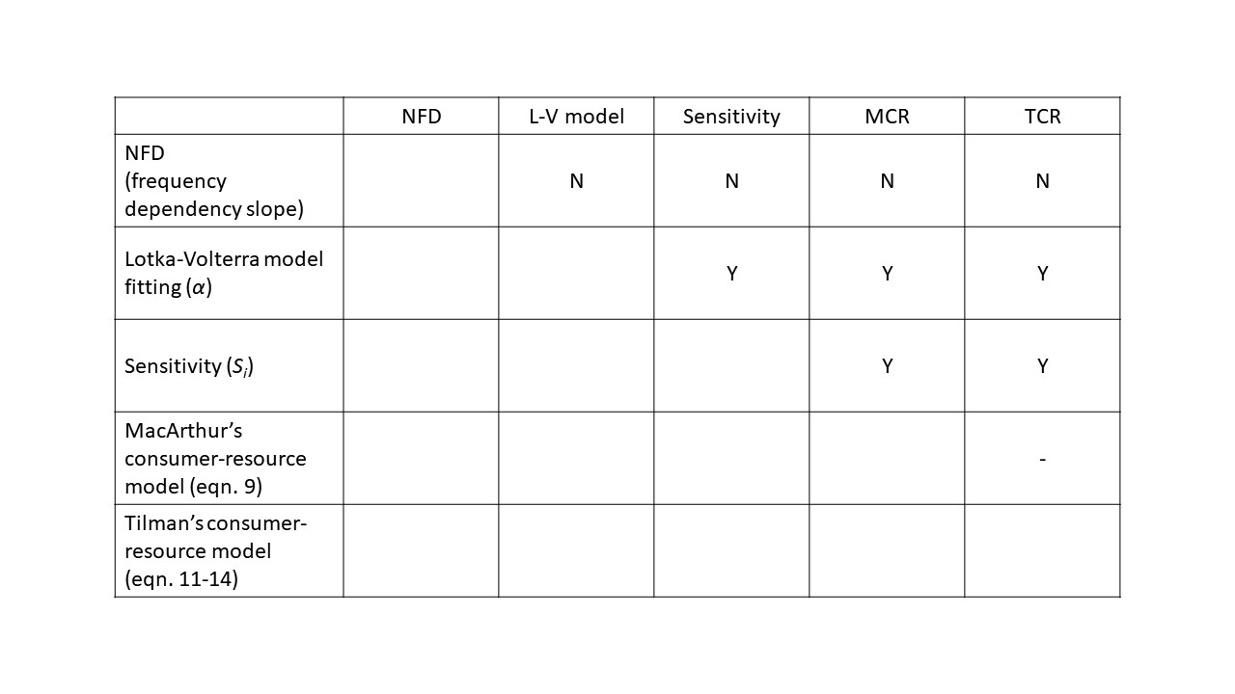

Table 2

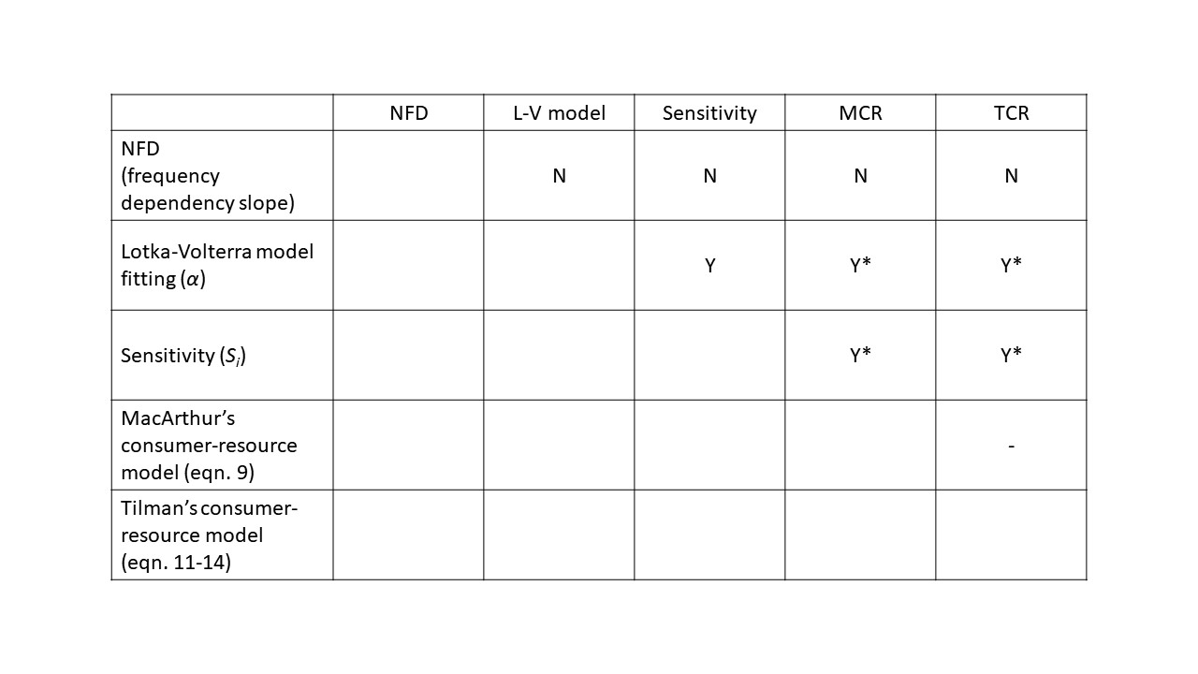

Table 3

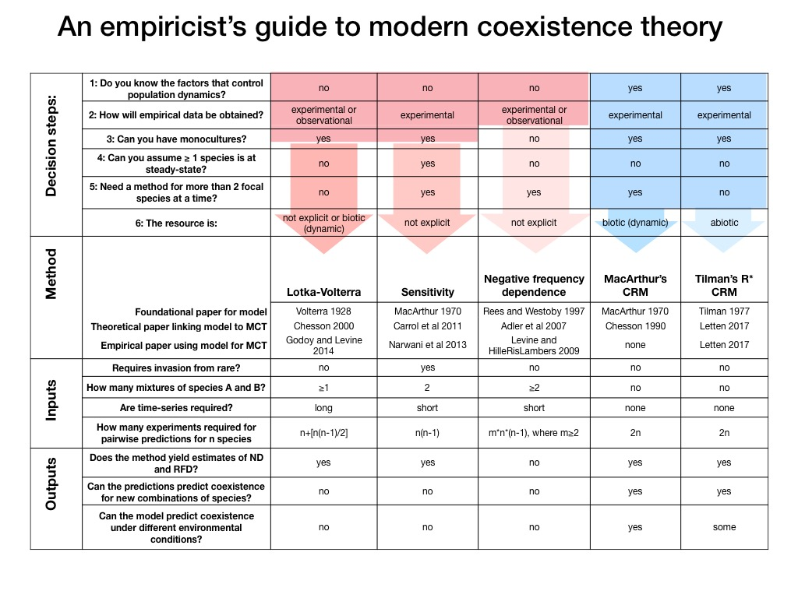

**Figures**

Figure 1



Figure 1. An example plot showing the negative frequency dependency (NFD) of species *i* (panel a.) and species *j* (panel b.). To calculate NFD, we first determined an arbitrary community biomass (B) and gradually increased the frequency of the focal species (species *i* in panel a. and species *j* in panel b.) to calculate the *per capita* growth rate of the focal species. Note that we directly calculated the *per capita* growth rate from equations of the Lotka-Volterra model not from numerical simulations. As the figure shows, the NFD depends on the arbitrarily community biomass (*B*). The resulting NFDs (slopes) match that are expected by equation 7. For example, when community biomass is 1 (dashed line in the middle), NFD of species i is -0.02 and NFD of species j is -0.045.

Figure 2



Figure 2. An example plot showing the estimation of αij from fitting Lotka-Volterra model to time series. The points represent the density of species i (open circles) and j (solid dots) respectively. The dashed lines are the two fitted growth curve. The species densities were generated by a Lotka- Volterra model and added some random noise.

Figure 3

Figure 3. An example plot showing the estimation of sensitivity (*Sij*) of species *i* invading species *j* (panel a.) or the reverse (panel b.). In both panels, solid dots are the growth curve species when growing alone and the open circles are the growth curve of species when invading the carrying capacity of the other species. To estimate the sensitivity of the focal species (e.g. species *i*), the competing species (species *j*) is fixed at the equilibrium and invade the focus species to estimate the invading growth rate of the focal species.

Figure 4



Figure 4. An example plot demonstrating the idea of niche difference (ND; *ρ*) in MacArthur’s con- sumer resource model. Consumption of species *j* on resource *l* (*cjl*) are plotted against consumption of species *i* on resource *l* (*cil*). The closeness between *cjl* and *cjl* are the closeness between these points to the 1:1 line and is expressed as *ρ*. For example, if all *cjl* are equal to *cil*, which means all points are on the 1:1 line, *ρ* is 1 and ND between species *i* and species *j* is 1−*ρ* = 0. The inset plot is an example plot showing the data required to measure consumption of species *j* on resource *l* (*cjl*).

Figure 5

Figure 5. Example plots showing the empirical data required to estimate R* in Tilman’s consumer resource model for species *i* and *j* on resource *i* and *j*. To obtain data one would need to grow the focal species (*i* and *j*) under different resource level and measure the corresponding *per capita* growth rate. *Rij* means the minimum level of resource *j* that still allows species *i* to have positive per capita growth rate. In this example scenario, species *i* (*j*)is limited by resource *j* (*i*), so that the $R_{ii}^{*}$ ($R_{ji}^{*}$) is greater than $R_{ij}^{*}$ ($R_{jj}^{*}$). The R* is the one being used to calculate *αii* and *αij* (*αjj* and *αji*) because they determine how sensitivity species *i* will be affected by the resource (resoruce *j*) that limits the growth rate of species *i*.